Project Report: Gym Management System

1. Project Title:
FitWithNithin Gym Management System

2. Introduction:
The FitWithNithin Gym Management System is a web-based application designed to streamline and automate operations in a modern fitness center. It provides an elegant, user-friendly interface for administrators and gym members. The system allows efficient member management, plan enrollment, login and check-in functionalities, and responsive dashboards for both staff and clients.

3. Objective:
To build a responsive, visually appealing, and highly functional gym management system that enhances the administrative workflow and user experience for both gym staff and members.

4. Features:
- Admin Portal
  - Secure login authentication
  - Dashboard with statistics and quick access
  - Add/Edit/Delete members
  - Manage staff
  - Track payments, plans, and reports
- Member Portal
  - Secure login authentication
  - Personalized dashboard
  - View membership details
  - Check-in functionality
  - View attendance, payments, and workout schedule
- Visitor Page
  - Overview of gym services
  - Trainer introductions
  - Plans and testimonials
  - Contact form with validation
- Responsive Design
  - Fully responsive on all screen sizes
  - Smooth animations and transitions

5. Technologies Used:
- Frontend: HTML5, CSS3, JavaScript (ES6+)
- UI Frameworks: None (Pure CSS for responsiveness)
- Libraries: FontAwesome (for icons only)
- Design Principles: Mobile-first design, Flexbox, Grid, Animations

6. System Architecture:
- HTML: Structure and semantics for all components
- CSS: Styling, responsive layout, transitions, animations
- JavaScript:
  - Login authentication logic
  - DOM manipulation for modals, forms, dashboards
  - Data handling for member and staff lists
  - Event listeners for interactive elements
  - Local storage for session tracking

7. Pages Overview:

7.1 Index Page:
- Hero section with gradient background
- Portal cards for admin and member login
- Hover effects and modern typography

7.2 Admin Login Page:
- Input validation
- Error messages with animation
- Simulated backend login with local data

7.3 Member Login Page:
- Similar to admin login
- Checks against predefined member credentials

7.4 Admin Dashboard:
- Sidebar navigation
- Dashboard statistics
- Member management with modals
- Data tables for members, plans, and reports

7.5 Member Dashboard:
- Personalized welcome message
- Quick stats (check-ins, payments, plans)
- Attendance tracking
- Workout schedules

7.6 Visitor Page:
- Hero with background SVG and gradients
- Services grid
- Plan cards with selection interaction
- Trainer bios and testimonials
- Contact form with validation

8. Functional Modules:

8.1 Authentication:
- Separate admin and member login logic
- Validation checks for email and password
- Use of local storage to manage session state

8.2 Member Management:
- CRUD operations via JavaScript
- Modal-based form interface
- Responsive tables updated dynamically

8.3 Dashboard Navigation:
- Sidebar with navigation links
- Each link switches section with animation
- Data visualization via stat cards and tables

8.4 Check-In System:
- Simulated member check-in
- Dynamic button feedback
- Timer-based reset for user interface

8.5 Contact Form (Visitor):
- Email validation and form check
- Loading simulation and confirmation

9. UI/UX Highlights:
- Consistent color theme (blue and cyan gradients)
- Rounded corners, smooth shadows, modern typography
- Animations (fade-in, slide-up, button hover effects)
- Mobile-responsive layout for all pages

10. Sample Code Excerpts:

Admin Login Validation (JS):
if (email === APP_CONFIG.adminCredentials.email &&
password === APP_CONFIG.adminCredentials.password) {
// Store login state and redirect
localStorage.setItem('adminLoggedIn', 'true');
window.location.href = 'dashboard-admin.html';
}

Member Table Update (JS):
APP_CONFIG.membersData.forEach(member => {
const row = document.createElement('tr');
row.innerHTML = `
<td>${member.name}</td>
<td>${member.email}</td>
<td>${member.plan}</td>
<td><span class="status ${member.status.toLowerCase()}">${member.status}</span></td>`;
tableBody.appendChild(row);
});

CSS Animations:
@keyframes fadeInUp {
from { opacity: 0; transform: translateY(30px); }
to { opacity: 1; transform: translateY(0); }
}

11. Testing & Validation:
- Manual testing across modern browsers
- Mobile responsiveness verified on various screen sizes
- Form input validation through JavaScript

12. Limitations:
- No backend/database (local storage only)
- No real authentication or encryption
- Data not persisted across sessions

13. Future Enhancements:
- Integrate with Firebase or backend API
- Add real-time chat or announcements
- Role-based access control
- Use IndexedDB or local database for persistent data
- Reports with visual charts (using Chart.js)

14. Conclusion:
The FitZone Gym Management System serves as a complete front-end solution for fitness center management. It showcases interactive UI design, clean code practices, modular structure, and responsive development. Future iterations can evolve this project into a production-grade platform.

15. Screenshots & UI Samples:
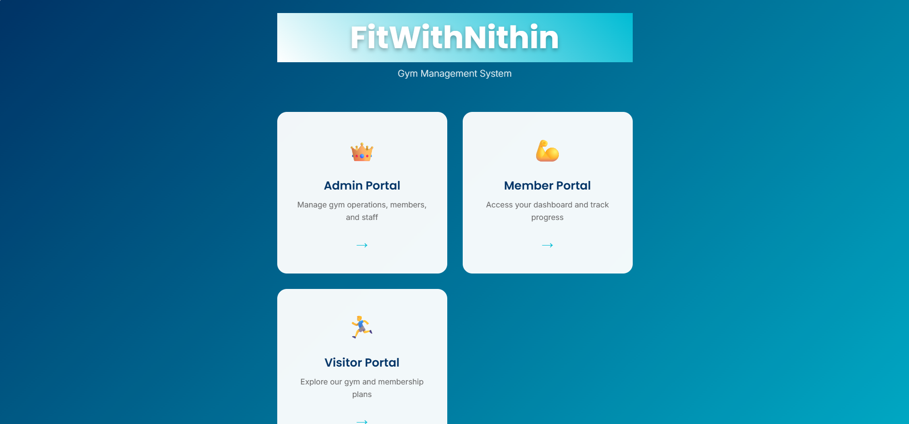
Admin Login Page :

Admin Dashboard :
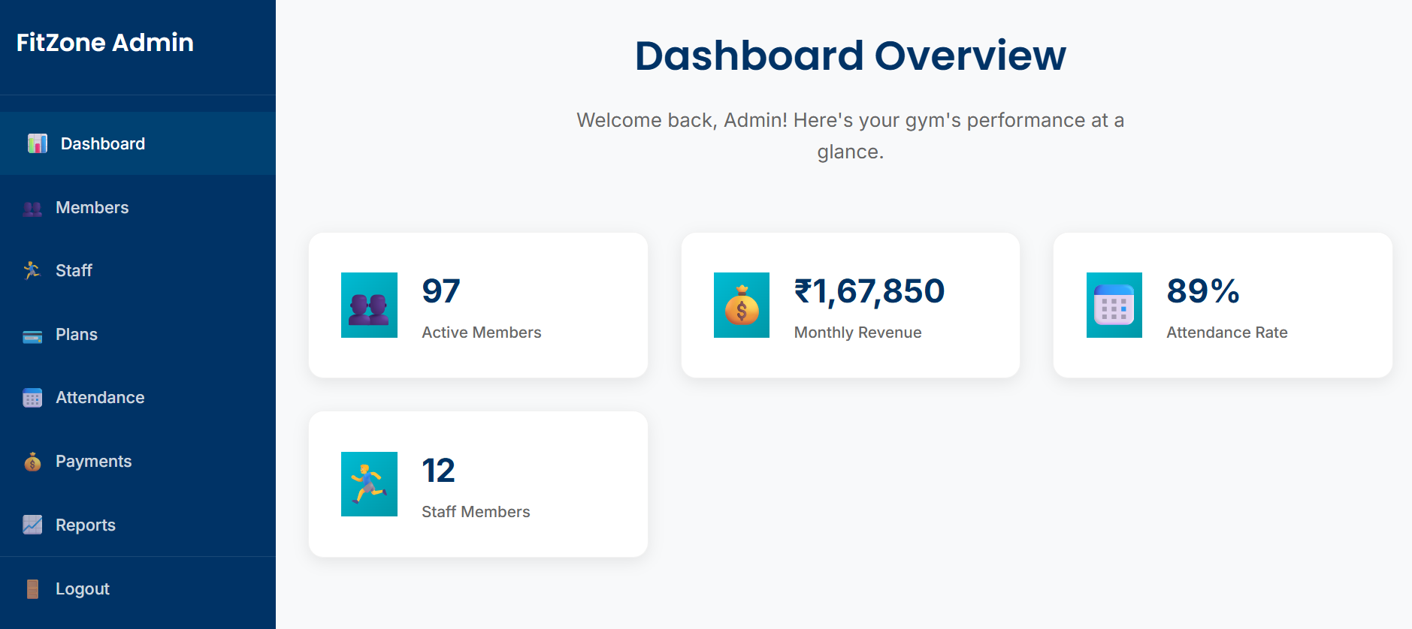

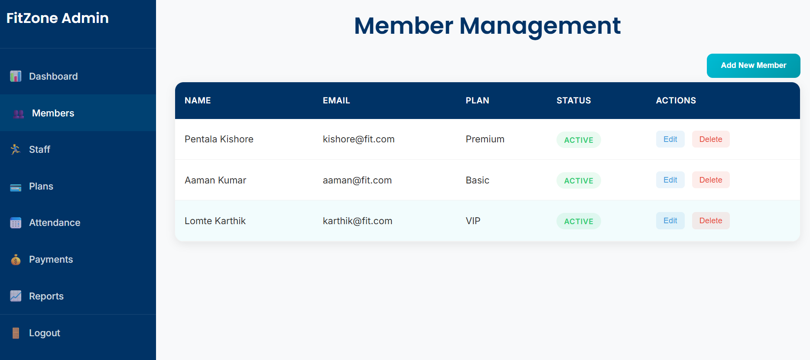
Membership Plans :
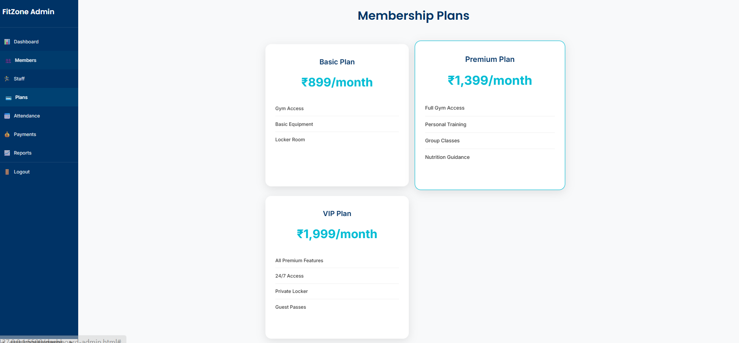
Attendance Log :
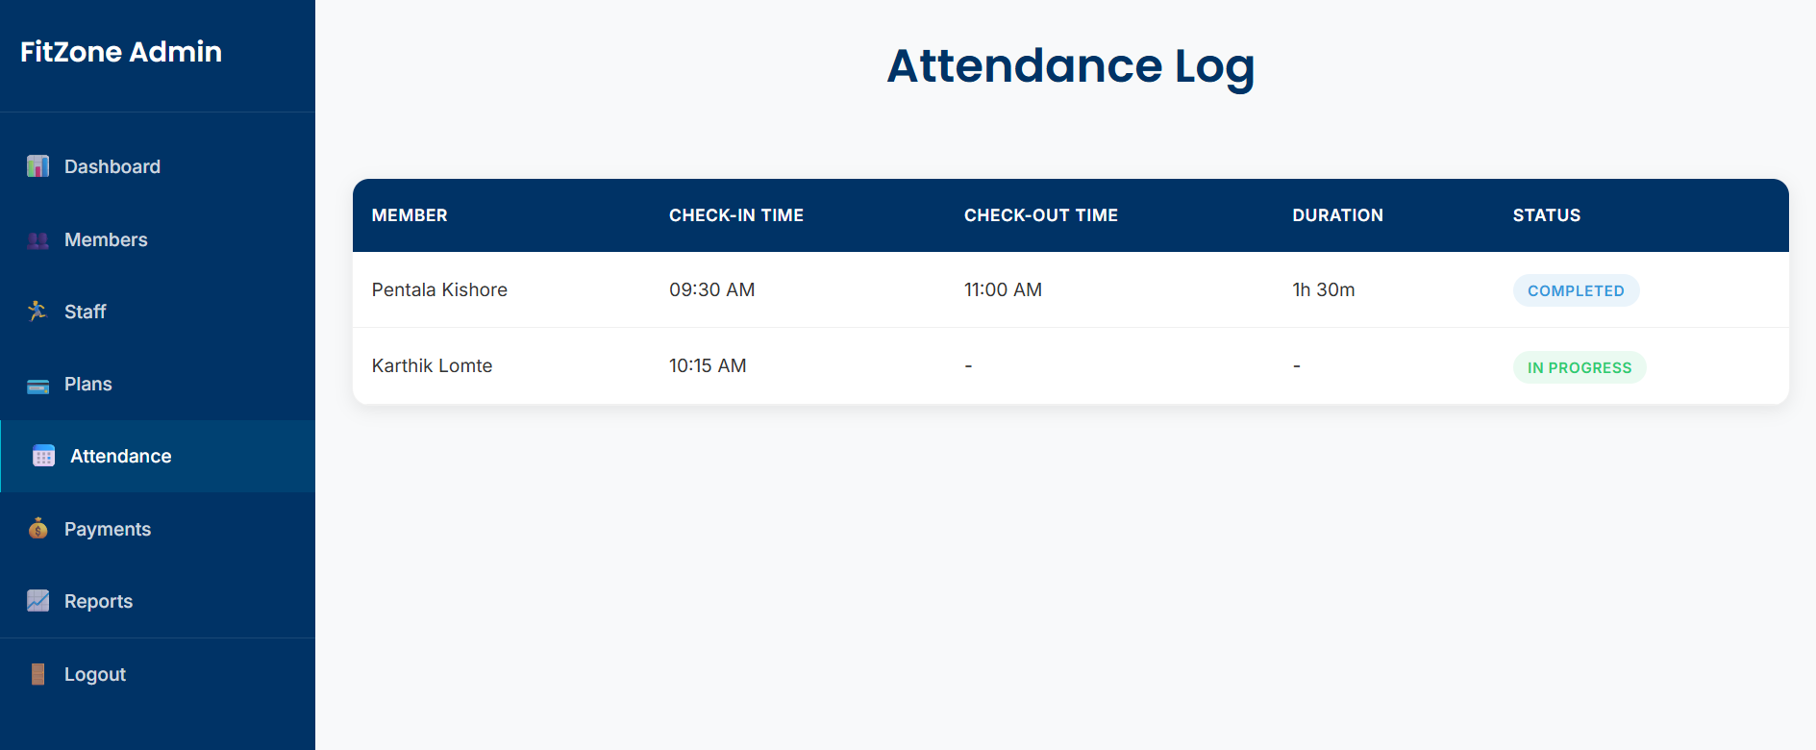
Payment Records :
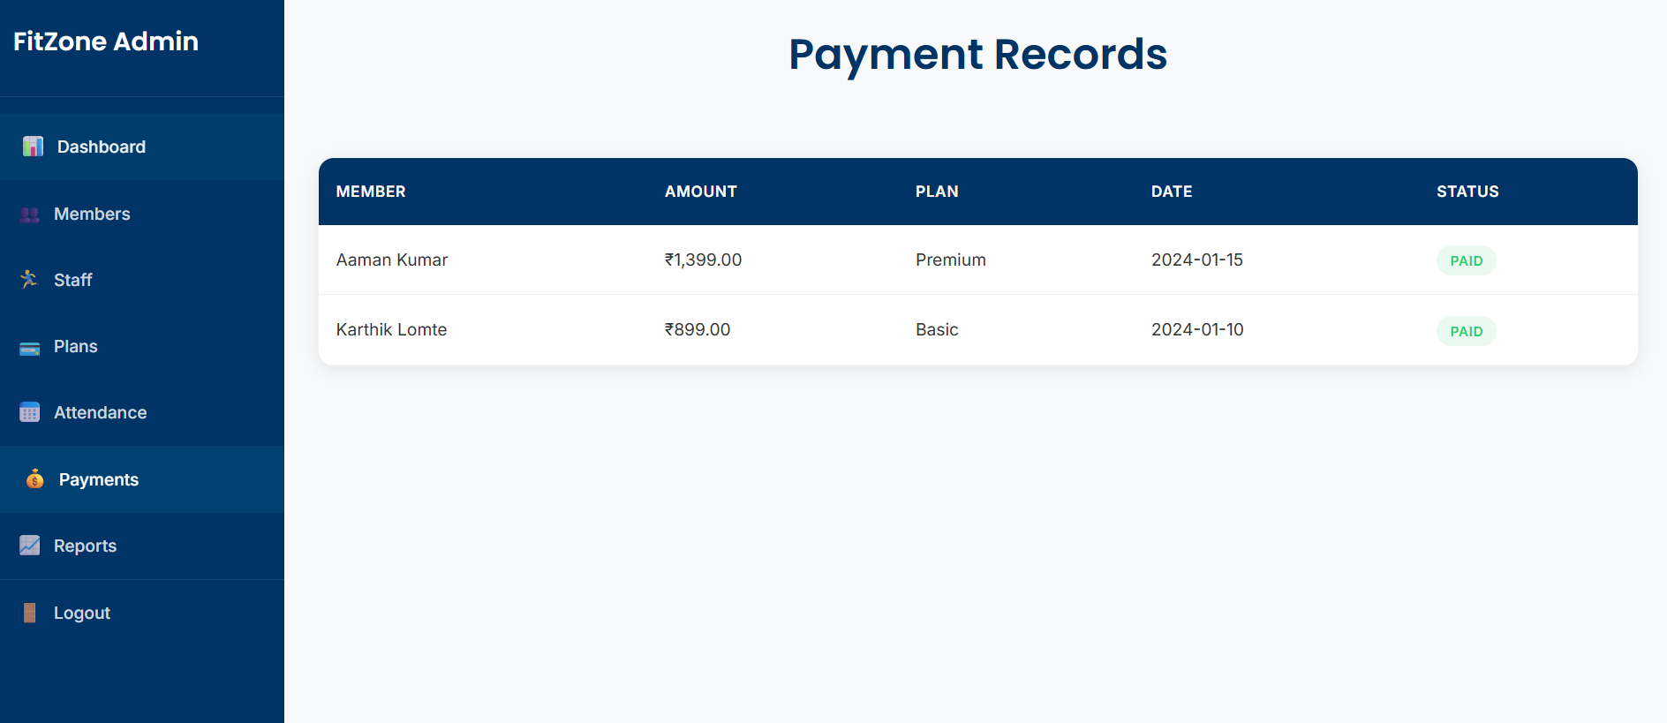
Reports & Analysis :
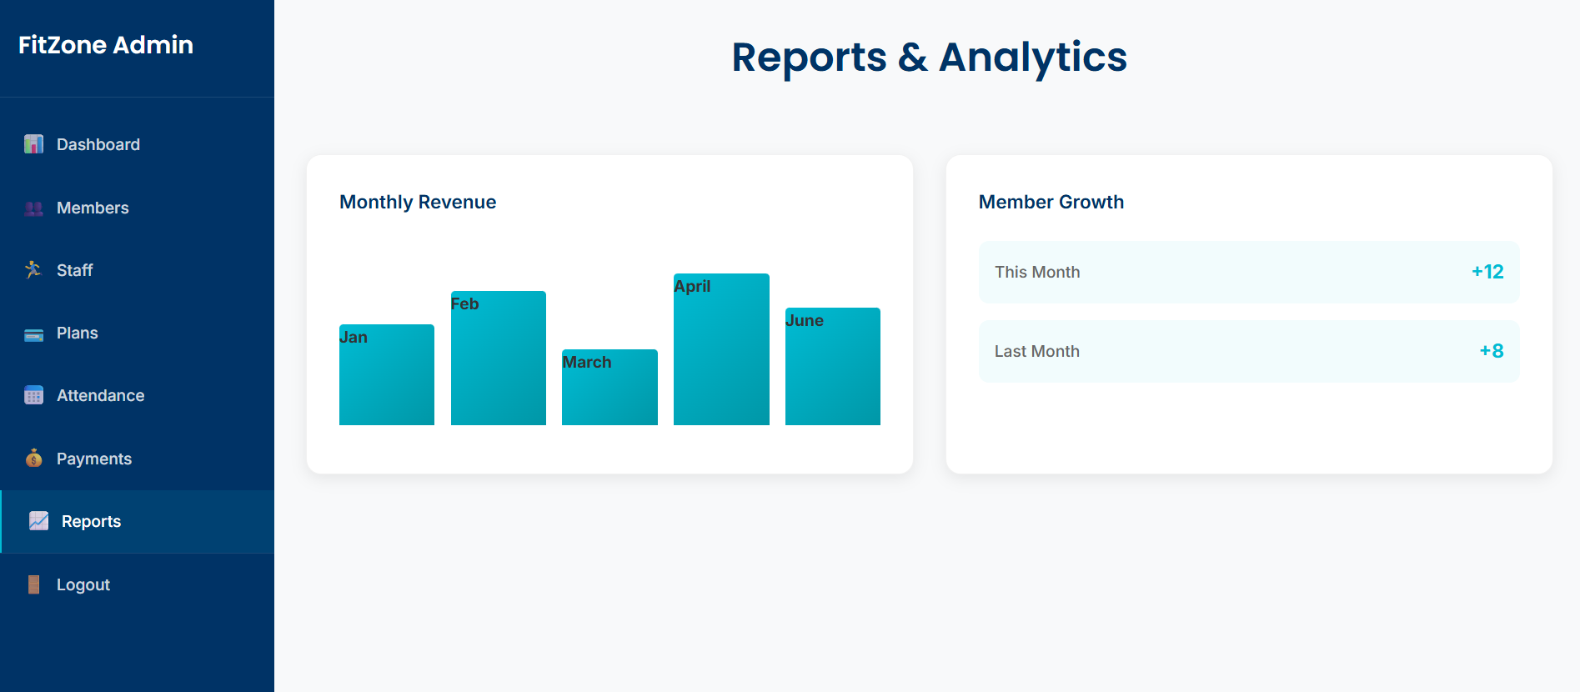
Member Login :
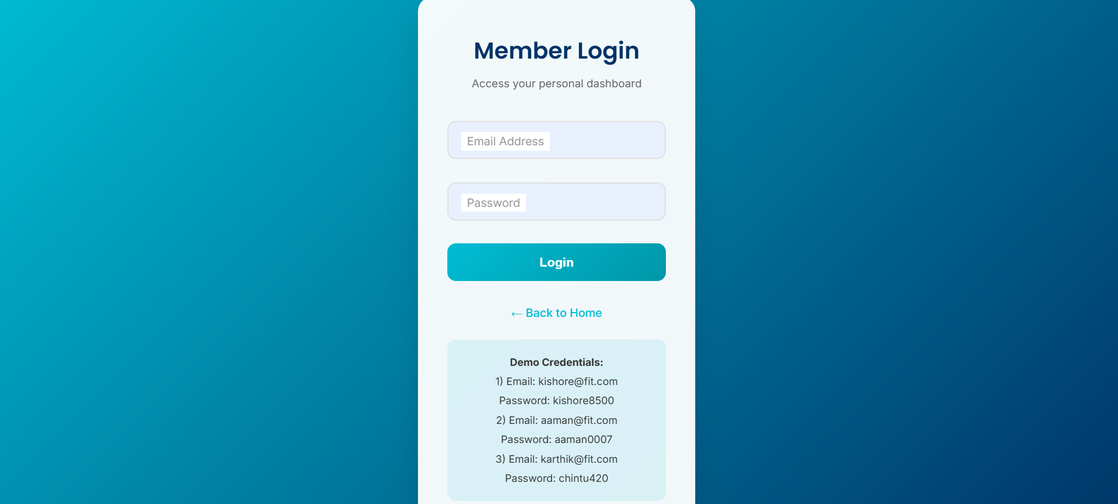

Member Portal :
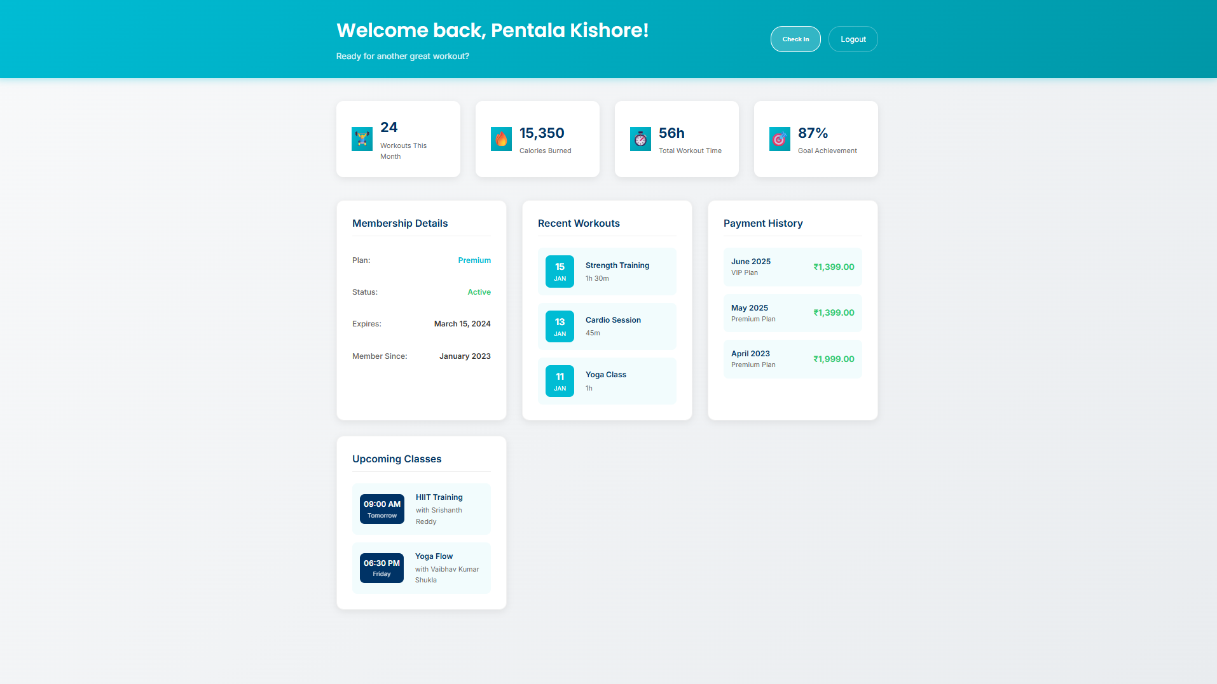
User/Visitor Page :
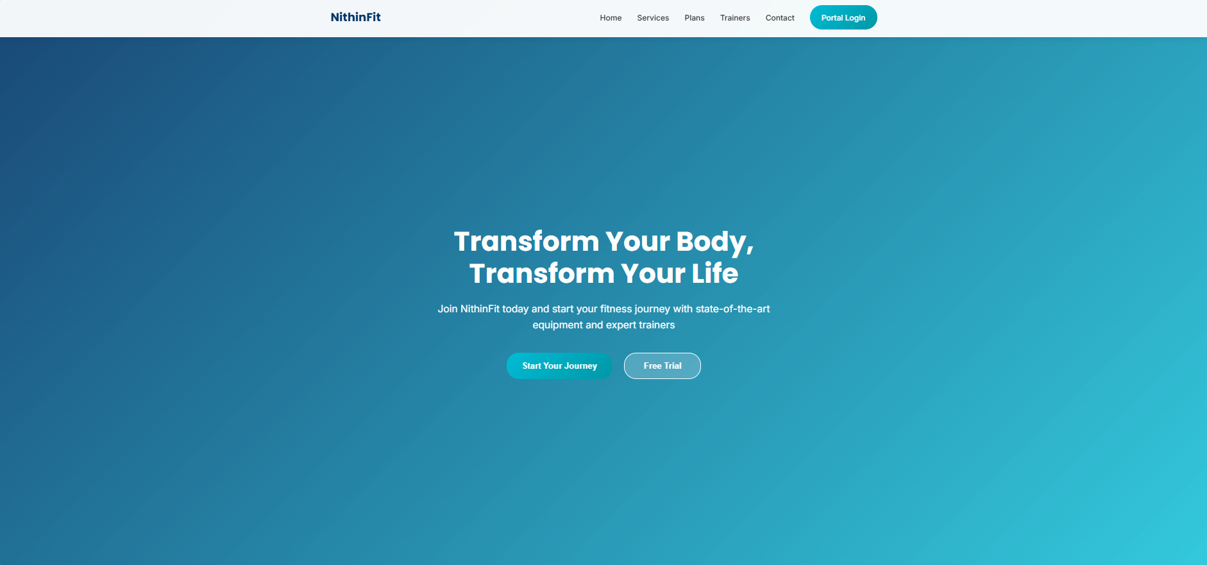
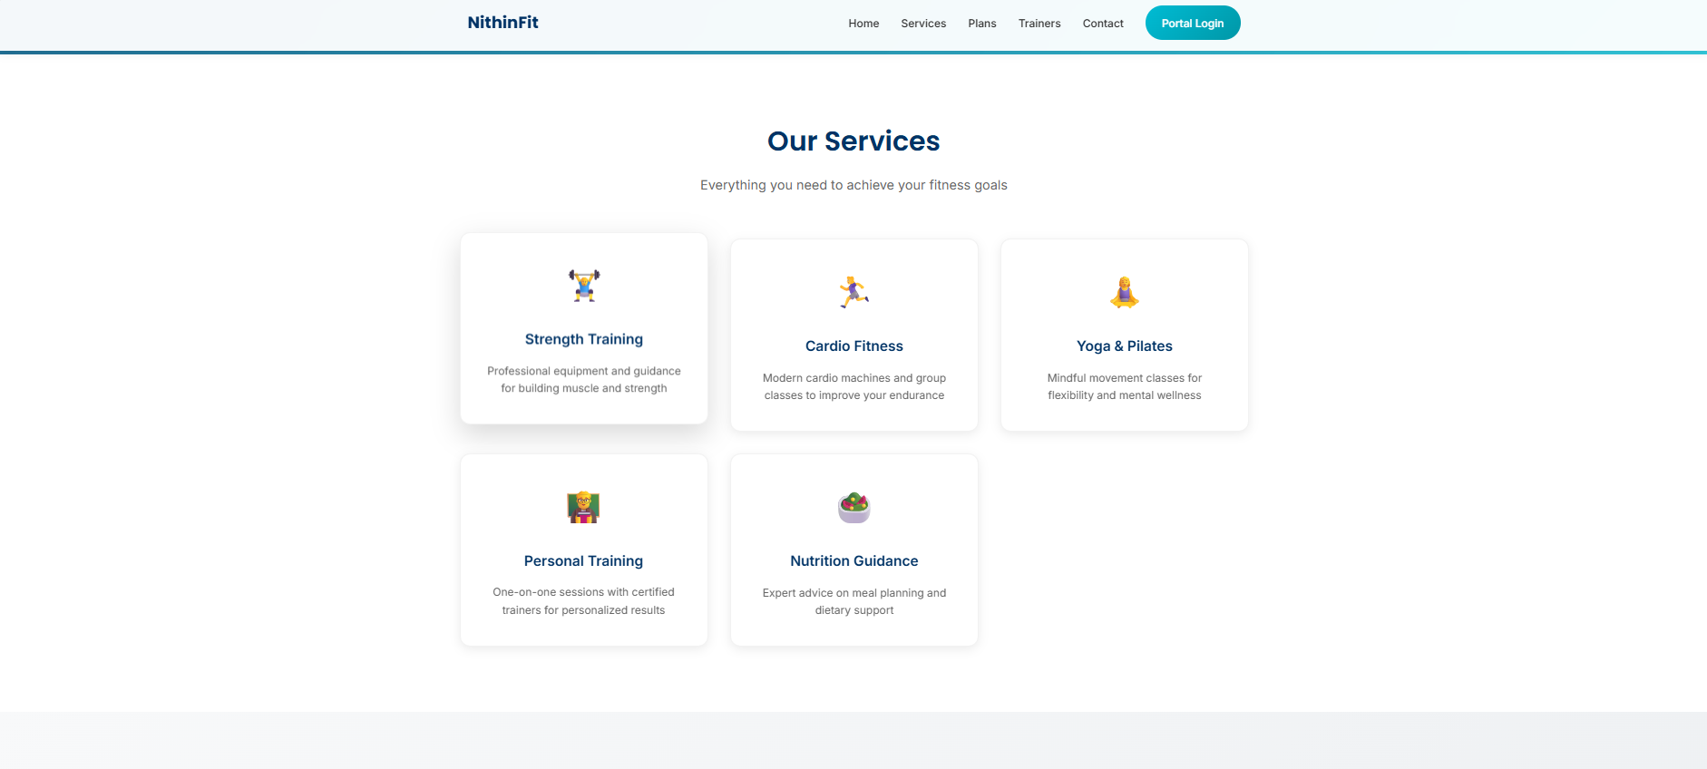
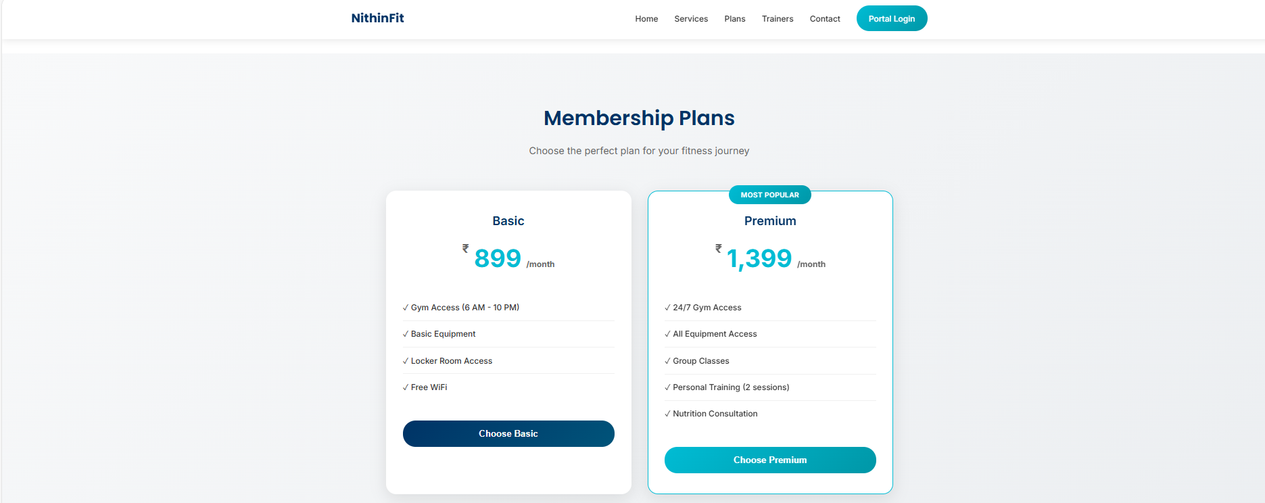
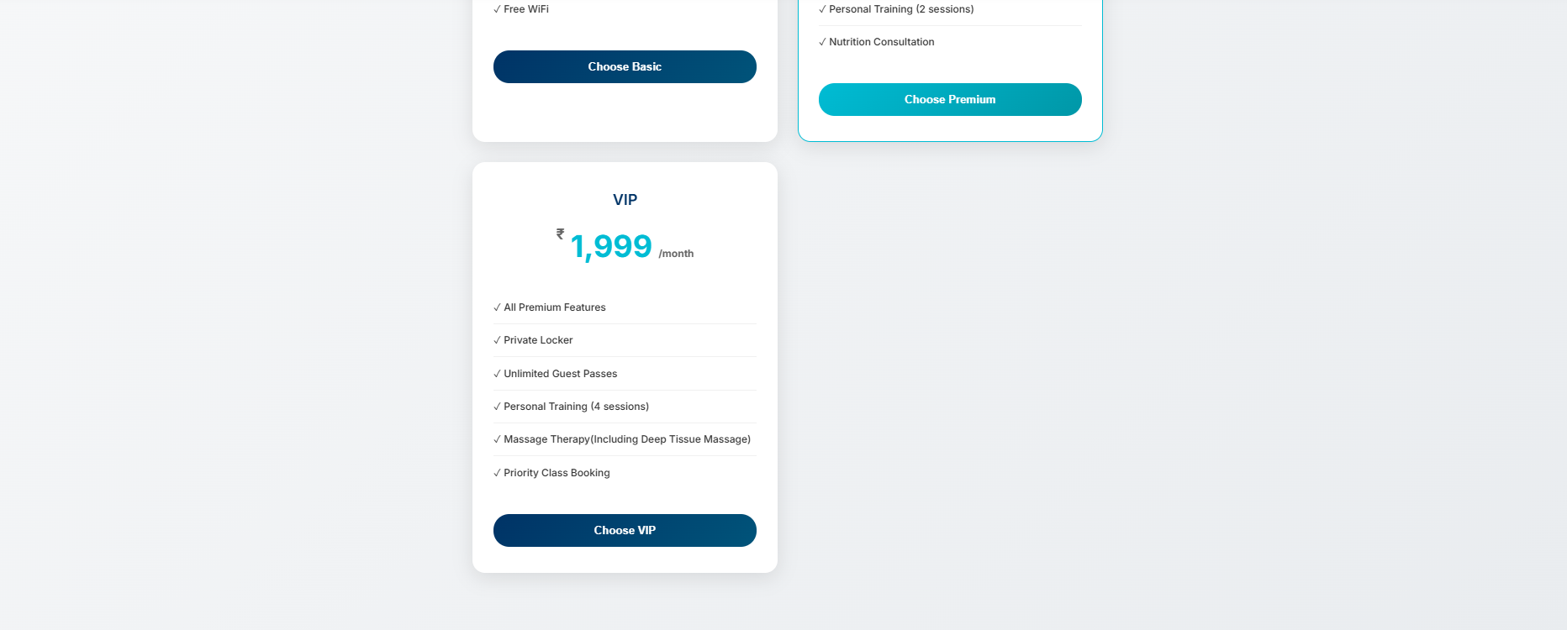
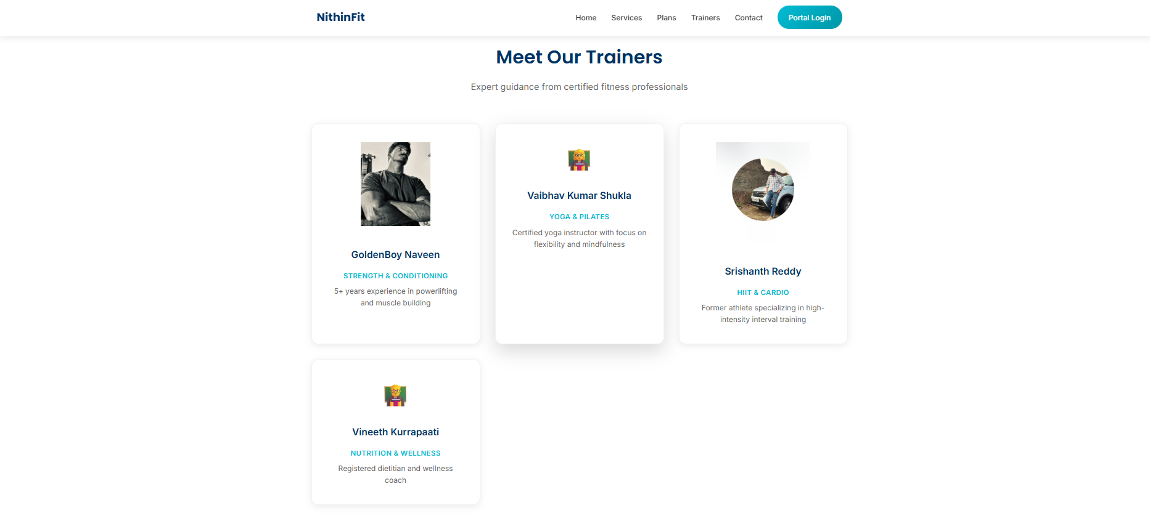
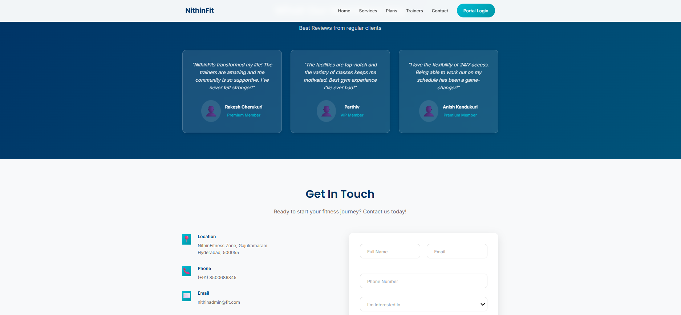
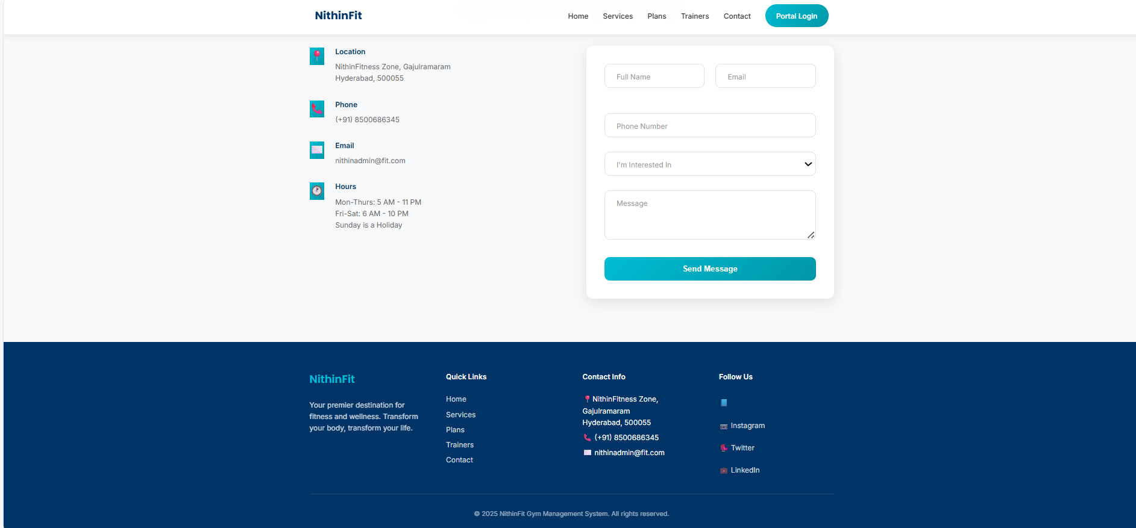
Architecture :
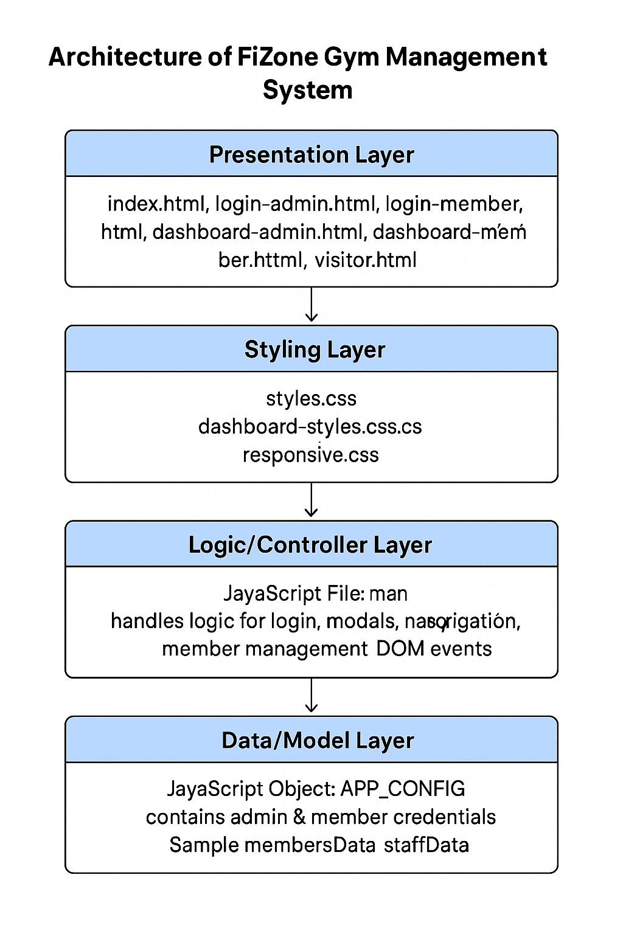

Annexure:
- HTML File Snippets
- Full CSS Theme
- JavaScript Modules
- User Credentials for Testing

------------------End of Report------------------

